==================================================
THRESHOLD: 0.40
==================================================

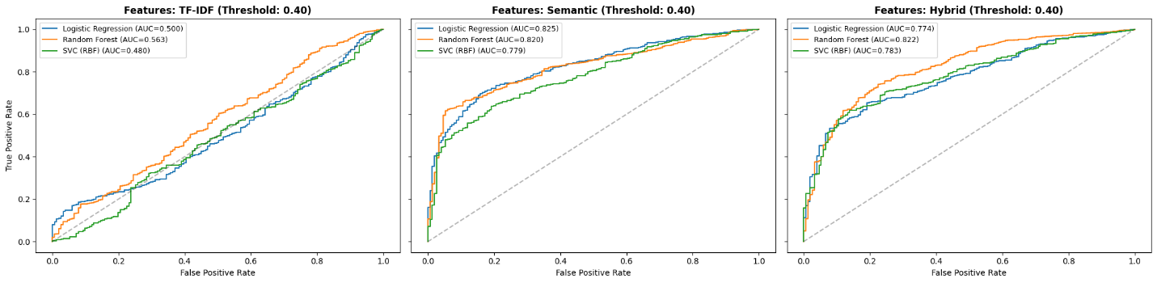
OVERALL BEST (Threshold 0.40): Hybrid + Random Forest (F1: 0.6302)

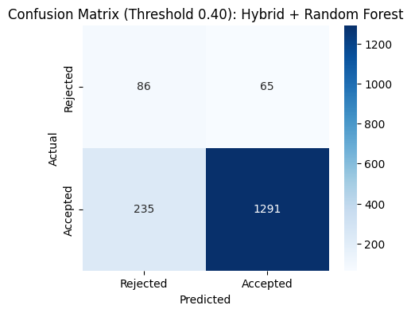
Classification Report (Threshold 0.40):
precision recall f1-score support

Rejected 0.27 0.57 0.36 151
Accepted 0.95 0.85 0.90 1526

accuracy 0.82 1677
macro avg 0.61 0.71 0.63 1677
weighted avg 0.89 0.82 0.85 1677

==================================================
THRESHOLD: 0.45
==================================================

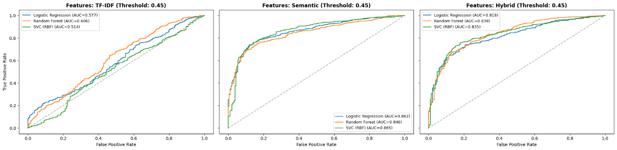
OVERALL BEST (Threshold 0.45): Semantic + Logistic Regression (F1: 0.6665)

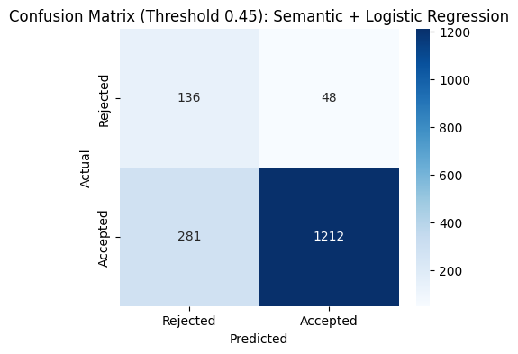
Classification Report (Threshold 0.45):
precision recall f1-score support

Rejected 0.33 0.74 0.45 184
Accepted 0.96 0.81 0.88 1493

accuracy 0.80 1677
macro avg 0.64 0.78 0.67 1677
weighted avg 0.89 0.80 0.83 1677

==================================================
THRESHOLD: 0.50
==================================================

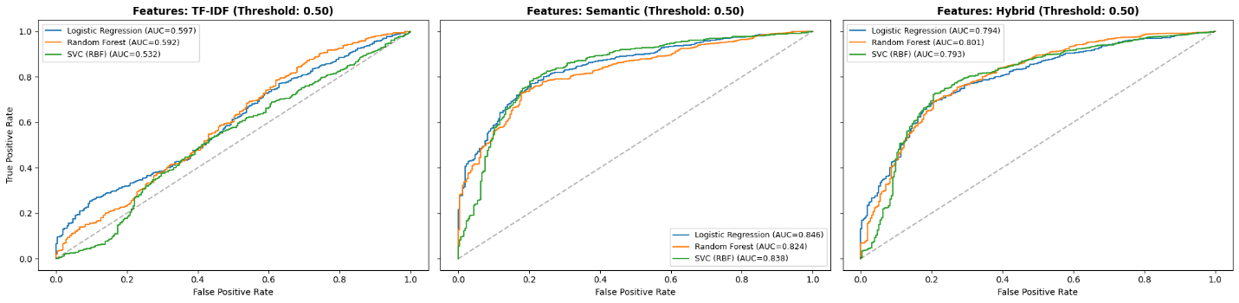
OVERALL BEST (Threshold 0.50): Semantic + Logistic Regression (F1: 0.6942)

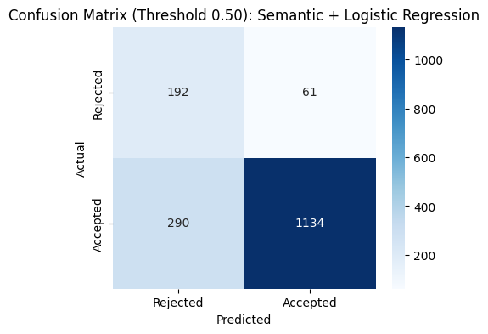
Classification Report (Threshold 0.50):
precision recall f1-score support

Rejected 0.40 0.76 0.52 253
Accepted 0.95 0.80 0.87 1424

accuracy 0.79 1677
macro avg 0.67 0.78 0.69 1677
weighted avg 0.87 0.79 0.81 1677

==================================================
THRESHOLD: 0.55
==================================================

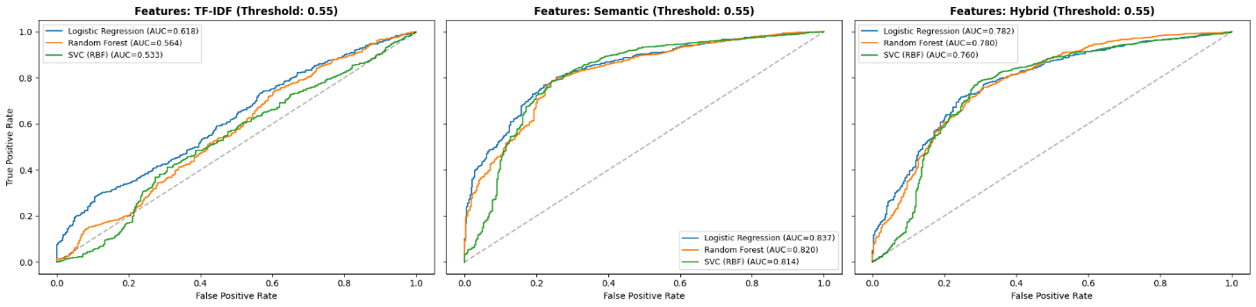
OVERALL BEST (Threshold 0.55): Semantic + Logistic Regression (F1: 0.7035)

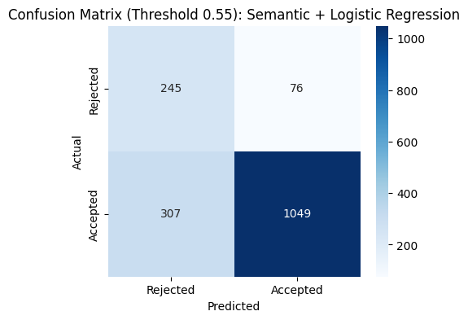
Classification Report (Threshold 0.55):
precision recall f1-score support

Rejected 0.44 0.76 0.56 321
Accepted 0.93 0.77 0.85 1356

accuracy 0.77 1677
macro avg 0.69 0.77 0.70 1677
weighted avg 0.84 0.77 0.79 1677

==================================================
THRESHOLD: 0.60
==================================================

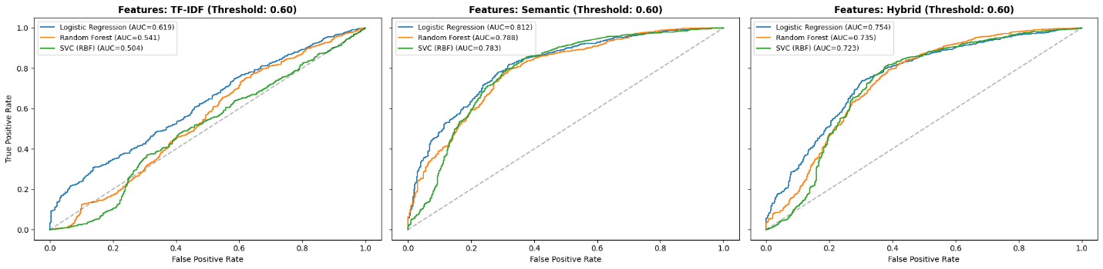
OVERALL BEST (Threshold 0.60): Semantic + Logistic Regression (F1: 0.7142)

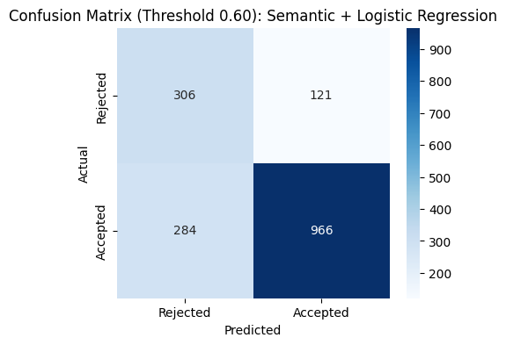
Classification Report (Threshold 0.60):
precision recall f1-score support

Rejected 0.52 0.72 0.60 427
Accepted 0.89 0.77 0.83 1250

accuracy 0.76 1677
macro avg 0.70 0.74 0.71 1677
weighted avg 0.79 0.76 0.77 1677

==================================================
THRESHOLD: 0.65
==================================================

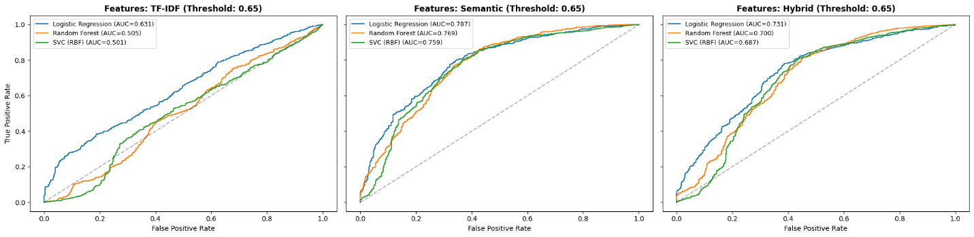
OVERALL BEST (Threshold 0.65): Semantic + Random Forest (F1: 0.7038)

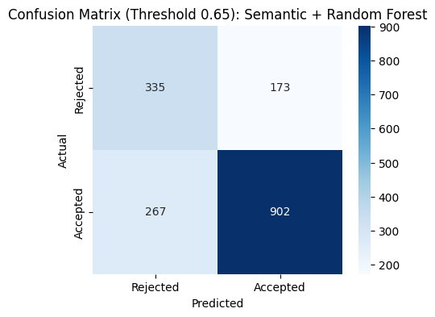
Classification Report (Threshold 0.65):
precision recall f1-score support

Rejected 0.56 0.66 0.60 508
Accepted 0.84 0.77 0.80 1169

accuracy 0.74 1677
macro avg 0.70 0.72 0.70 1677
weighted avg 0.75 0.74 0.74 1677

==================================================
THRESHOLD: 0.70
==================================================

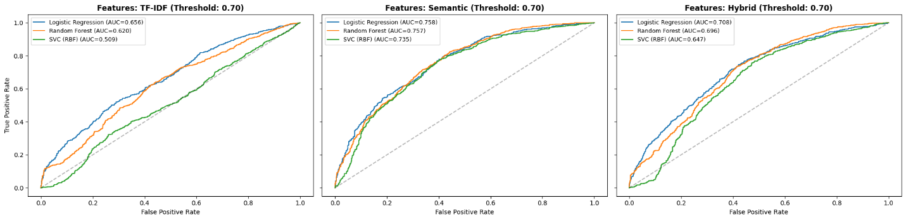
OVERALL BEST (Threshold 0.70): Semantic + Logistic Regression (F1: 0.6825)

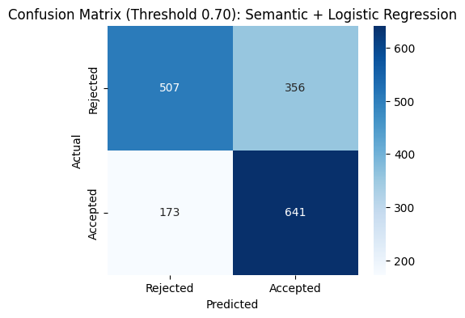
Classification Report (Threshold 0.70):
precision recall f1-score support

Rejected 0.75 0.59 0.66 863
Accepted 0.64 0.79 0.71 814

accuracy 0.68 1677
macro avg 0.69 0.69 0.68 1677
weighted avg 0.70 0.68 0.68 1677

==================================================
THRESHOLD: 0.75
==================================================

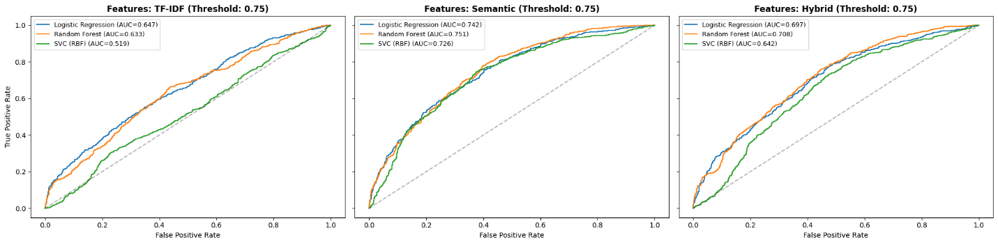
OVERALL BEST (Threshold 0.75): Semantic + Random Forest (F1: 0.6696)

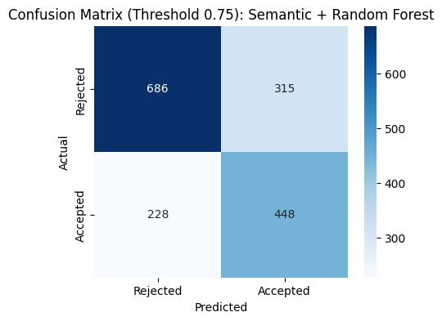
Classification Report (Threshold 0.75):
precision recall f1-score support

Rejected 0.75 0.69 0.72 1001
Accepted 0.59 0.66 0.62 676

accuracy 0.68 1677
macro avg 0.67 0.67 0.67 1677
weighted avg 0.68 0.68 0.68 1677

==================================================
THRESHOLD: 0.80
==================================================

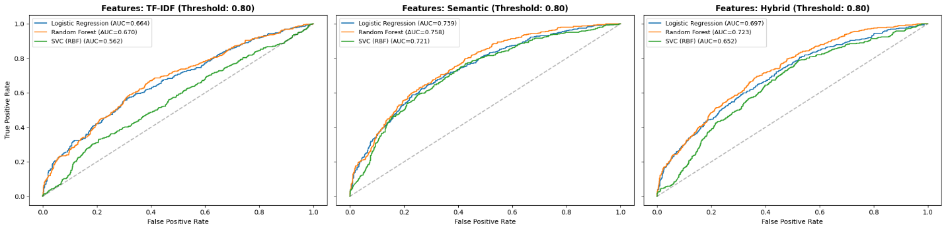
OVERALL BEST (Threshold 0.80): Semantic + Random Forest (F1: 0.6308)

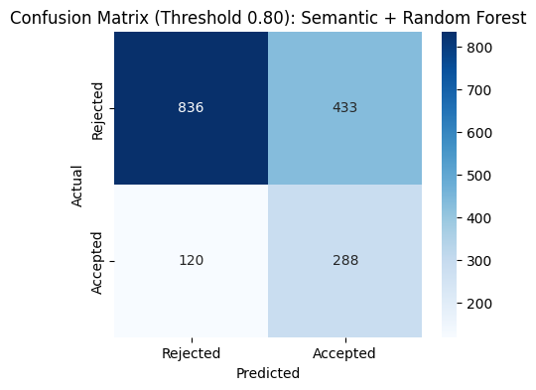
Classification Report (Threshold 0.80):
precision recall f1-score support

Rejected 0.87 0.66 0.75 1269
Accepted 0.40 0.71 0.51 408

accuracy 0.67 1677
macro avg 0.64 0.68 0.63 1677
weighted avg 0.76 0.67 0.69 1677

==================================================
THRESHOLD: 0.85
==================================================

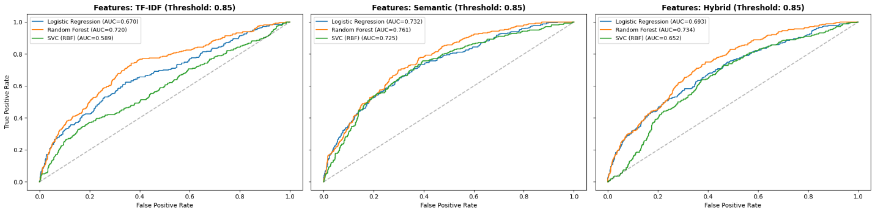
OVERALL BEST (Threshold 0.85): TF-IDF + Random Forest (F1: 0.6187)

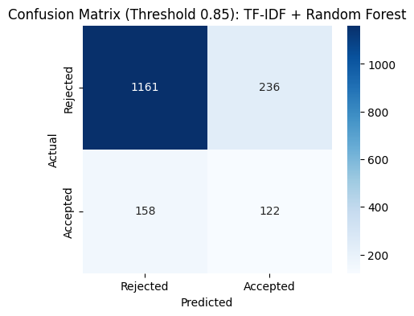
Classification Report (Threshold 0.85):
precision recall f1-score support

Rejected 0.88 0.83 0.85 1397
Accepted 0.34 0.44 0.38 280

accuracy 0.77 1677
macro avg 0.61 0.63 0.62 1677
weighted avg 0.79 0.77 0.78 1677

==================================================
THRESHOLD: 0.90
==================================================

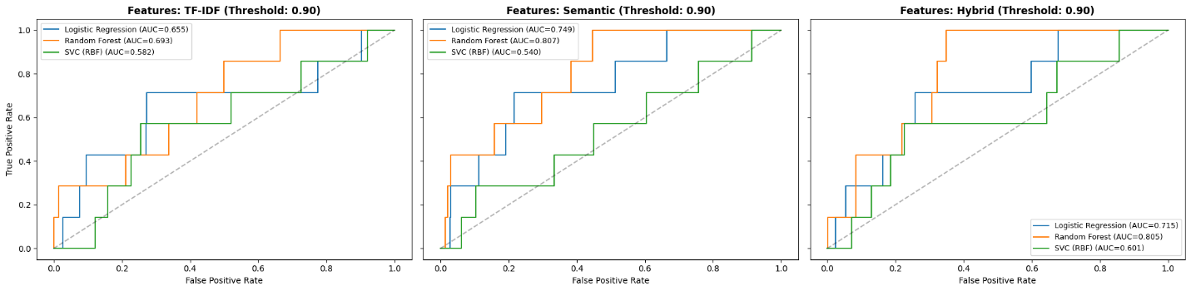
OVERALL BEST (Threshold 0.90): TF-IDF + Random Forest (F1: 0.5446)

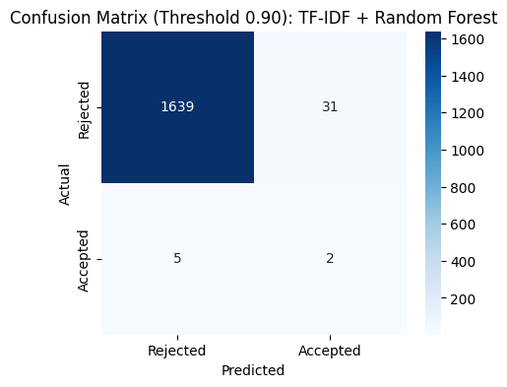
Classification Report (Threshold 0.90):
precision recall f1-score support

Rejected 1.00 0.98 0.99 1670
Accepted 0.06 0.29 0.10 7

accuracy 0.98 1677
macro avg 0.53 0.63 0.54 1677
weighted avg 0.99 0.98 0.99 1677

